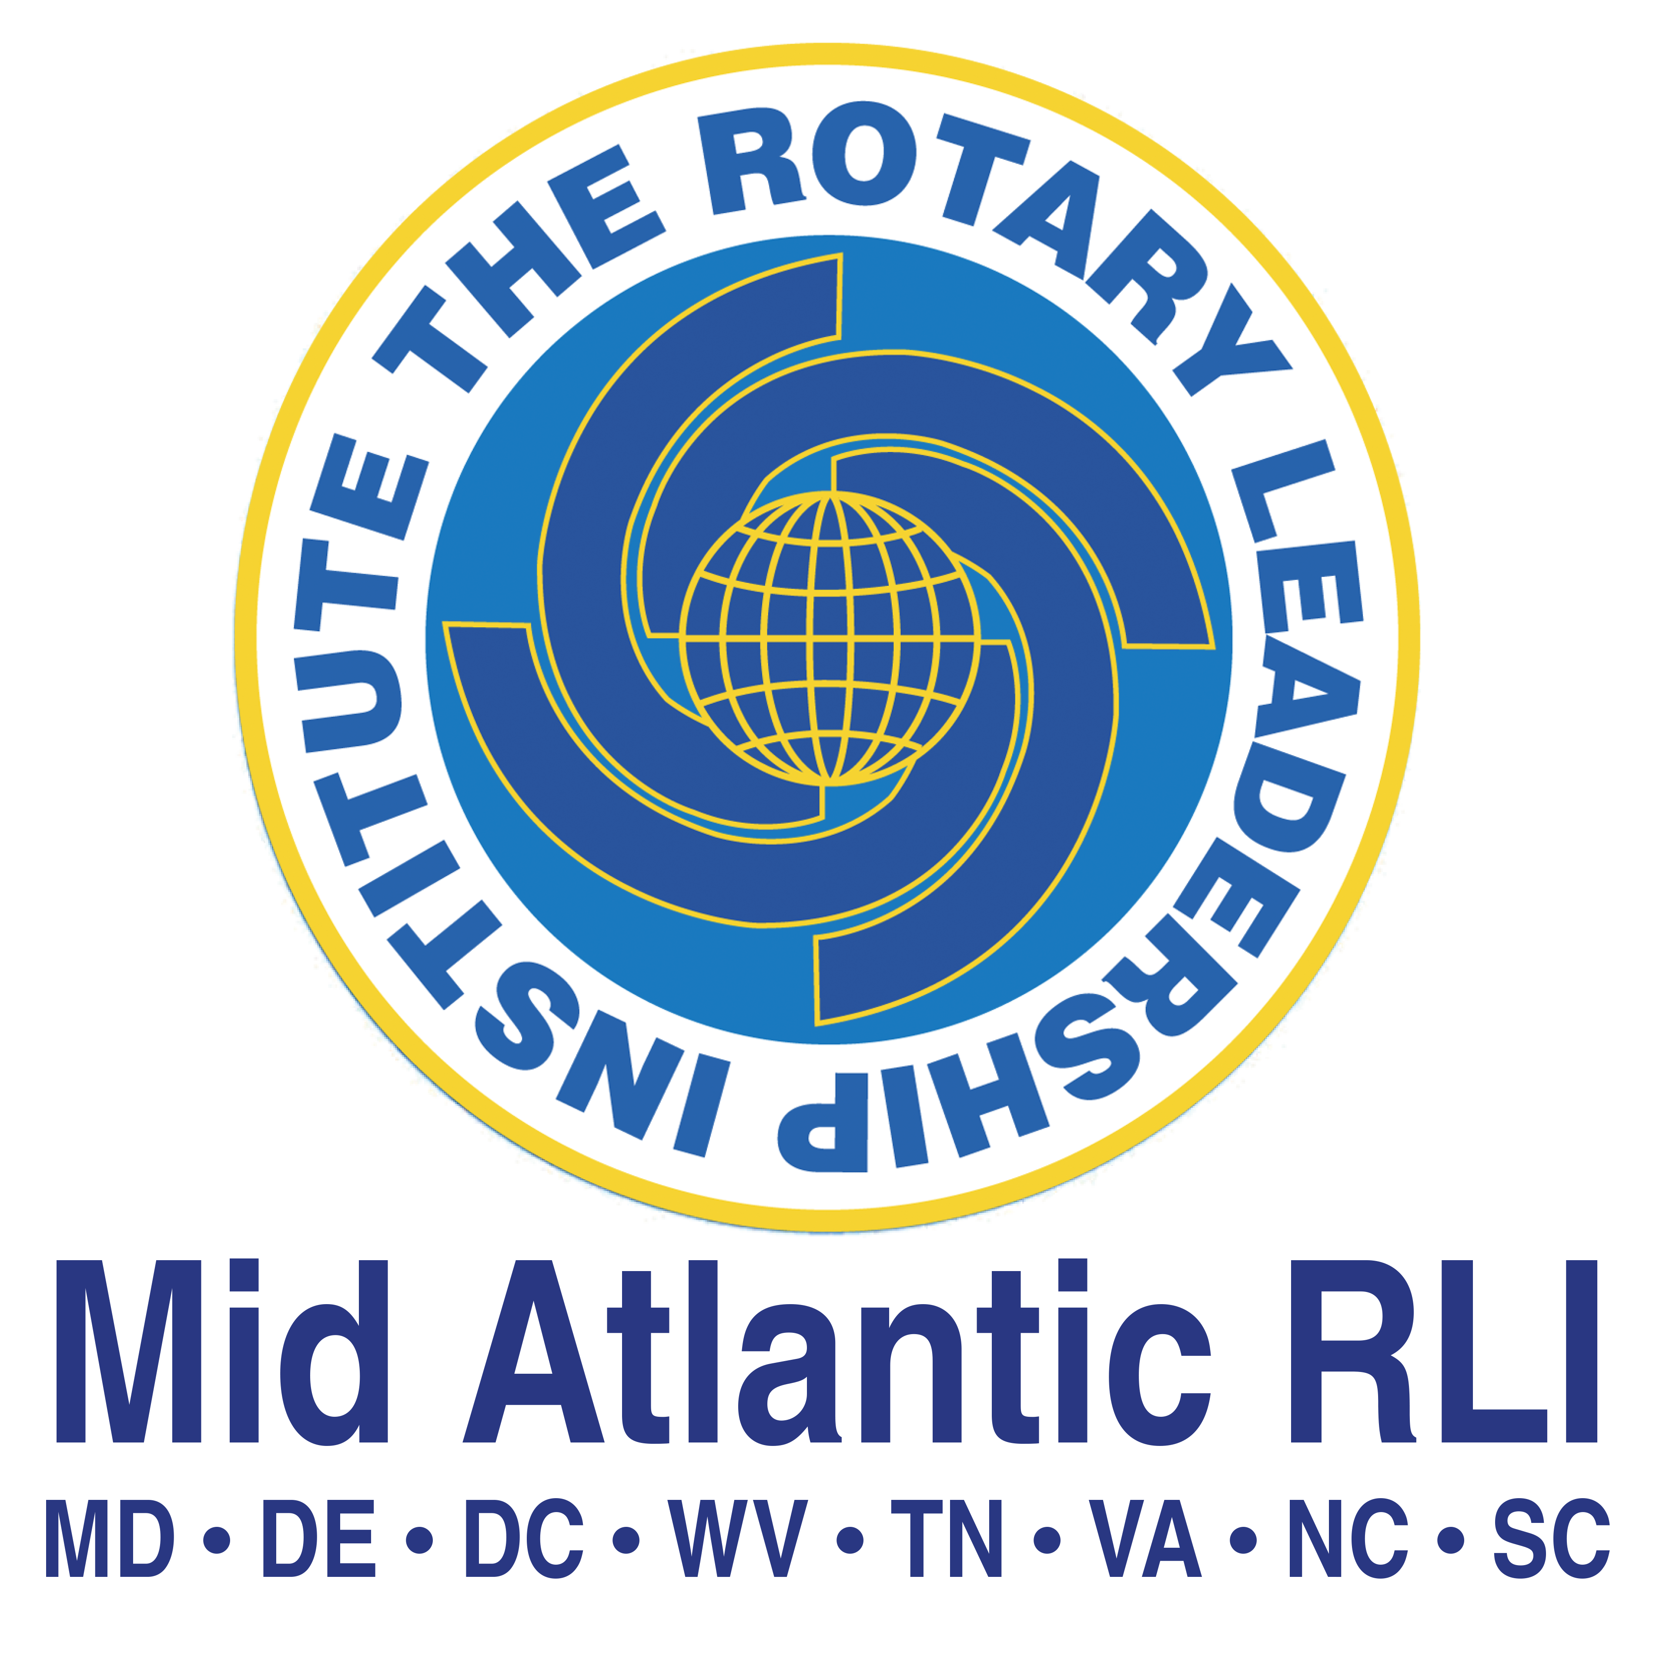

Mid-Atlantic Rotary Leadership Institute
(MARLI) Board of Directors Meeting
April 2, 2025

Welcome
Meeting called to order by Chair, Sean Sawyer at: 6:06 pm

Roll was taken by the Secretary, and a quorum was determined with 11 voting members present.

Board members Present:

Member | Present
Chair: PDG Sean Sawyer | x
Vice Chair and Nominating Committee Chair: Chris Stevenson | x
iPast-Chair and Secretary: Marcia Scheideman | x
Treasurer: Barbara Dresser | x
Faculty Trainer: Chris Zabriskie | x
Director: Lin Kelly - 2025 | x
Director: Tarek Monier - 2025 | x
Director: Bea Carson - 2025 | x
Director: Tom Ledbetter - 2026
Director: SuAnne Bryant (Legal) - 2026 | x
Director: Debbie Scott - 2027
Director: Roger Harrell - 2027
Director: Renee Stubbs – 2026x | x
Director: Marilyn Cruz - 2025 | x

Member Representatives and Guests
Numerous Regional Coordinators, District Chairs and guests attended including the following:
- Stan Keeler
- Rudy Garcia
- Steve Grossman
- Ralph Menzel
- RJ Ritchey
- Allison Burkett
- Tara Abernathy
- Jane Stout
- Craig Stout

Welcome and Introductions by Chair – Sean Sawyer
Chair Sean distributed Mid-Atlantic RLI flowchart and explained rationale behind placement of positions. Bea agreed to put it on the website.

Recommendation made to dispense with the reading of the minutes. Chris called upon Sean to entertain a motion to approve the minutes. SuAnne Bryant moved, and Tarek Moneir seconded the motion. Motion carried.

Treasurer Report
- Barbara Dresser, Treasurer gave report.
- Financials not available this early in the month. Numbers will be available once reconciliation is completed

Welcome of New Board
Renee Stubbs and Marilyn Cruz officially welcomed board by chair and current members

PI Committee
- Working on a Road Show to increase presence at district and zone events
- Timelines are being developed
- Talked about newsletter and made decision that it would not be as effective since the audience would be internal RLI members
- Planning Alumni event for Kannapolis event in July

Bylaws Committee
- No report

Faculty Trainer
- January released 2025 Participant Gude as revised
- Currently working on Faculty Guides
- By request, participant guides are being put into writable format – this would appeal to a younger audience that prefers to access guides online but maintains option of taking notes
- Sean described the significance of writable format and current policy
- Chris announced the teams that will lead various trainings planned for July.
  - Marcia – NFT
  - Chris/Rod Funderburk – Graduate Courses
  - Allison Burket will work on staffing Parts 1, 2, and 3
- Concern was expressed regarding the potential challenges in staffing all offerings with limited active faculty available

Finance
- Nametags – reached out to FiveStar and Russell Hampton to get estimates
- Chris Zabriskie will provide accurate count
- Documents distributed – 1) Cost reduction – SuAnne Bryant moved Tarek seconded - motion passed; 2) Faculty and staff stipend request
- Question raised whether the use of points is allowable and still claim reimbursement; 3) Events expenditures form
- SuAnne moved and Lin seconded motion to accept both Faculty/Staff stipend request and Events expenditure form – both motions passed
- No progress in terms of the tax issues – not formal writing has been issued

Nominating Committee
- July will see four open seats on the Board
- Collecting interested people to add decisions based on skills advantageous to RLI leadership
- Will then send assessments
- Ralph thanked individual members and Board as a whole for wonderful experience with RLI and leaving with mixed emotions into another Rotary opportunity

Old Business
- Documents are being organized and moved to relevant locations on DACdb
- Welcome letter developed and being reviewed by Bea and Lin
- Post learning evaluations live since January – RC doing great at uploading prior to event
- Chris Zabriskie is monitoring the use

New Business
- Chris Zabriskie explained policy documents
- Introduced four new documents including: NFT onboarding as an example of such a document; Faculty Recertification/Certification regarding Faculty Updates; RLI Facilitation Exception; Waiver Authority
- Sean requested power point deck for policies so he can move them forward.
- Issue raised about scheduling and multiple events that overlap on same day. Agreed that staffing Parts 1,2,3 takes priority.
- Lee Hudson – Lifetime Achievement Award; Chris Stephenson to take the lead and work with committee to develop criteria.
- Presentation of Virtual – only Event Chair Pam Kreis volunteered for the position and submitted ideas to share to board when proposed.
- District 7280 reached out to Sean to see if they could switch their RLI program to Mid-Atlantic RLI – Chris Stevenson explored their interest by attending district meetings in that area. Bea moved Chris seconded MARLI extend invitation to 7280 to join MARLI activities this spring/summer in preparation for possibly moving their RLI home – Motion carried
- Sean presented the proposed schedule for the July meeting.
- Operations Chair position proposed and discussed as a possibility to spread out workload.

Meeting Adjourned – 8:00pm

Next Quarterly Board Meeting –October TBA

Annual Meeting Summer Faculty Update
July 12-13, 2025, Rowan Cabarrus Community College, Kannapolis, NC

